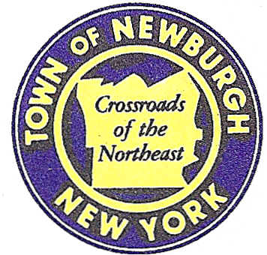

TOWN OF NEWBURGH
_______Crossroads of the Northeast __________________________
OLD TOWN HALL
308 GARDNERTOWN ROAD NEWBURGH, NEW YORK 12550

PLANNING BOARD
JOHN P. EWASUTYN, CHAIRMAN
TELEPHONE 845-564-7804
FAX 845-564-7802
E-MAIL: planningboard@townofnewburgh.org

PLANNING BOARD AGENDA

JANUARY 8, 2015

*PLEASE NOTE: The Planning Board Meeting will start at 7:00 P.M. and all Applicants/Representatives
are to be present at that time. The Meeting will be held in the Meeting Room of Town Hall,
located at 1496 Route 300, Newburgh NY.*

- Sprint Nextel (2014-28)  39 North Plank Road (Mid Valley Mall)  Sec. 75; Blk. 1; Lot 11  Zone: B  Rep: Cara M. Bonomolo, Esq.  Snyder & Snyder, LLP  94 White Plain Road  Tarrytown, NY 10591 | PUBLIC HEARING  WIRELESS TOWER UPGRADE
- Petrick Timber Harvest (2014-29)  178 North Fostertown Road  Sec.17; Blk.2; Lot 68  Zone: AR  Rep: Chris Prentis  Lower Hudson Forestry  P.O. Box 756 Nyack, NY 10960 | PUBLIC HEARING  TIMBER HARVEST
- Webb Properties (2014-10)  Route 17K & Auto Park Place  Sec. 97; Blk. 2; Lots 35 & 43  Zone: IB  Rep: A. Diachishin & Associates  115 Yankee Folly Road  New Paltz, NY 12561 | PUBLIC HEARING  SITE PLAN
- Birks Realty/Webb Properties (2014-30)  Unity Place, Auto Park Place & Route 17K  Sec. 97, Blk. 2, Lots 11.2, 13.2, 32, 35 & 43  Zone: IB  Rep: A. Diachishin & Associates  115 Yankee Folly Road  New Paltz, NY 12561 | PUBLIC HEARING  SUBDIVISION & LOT LINE CHANGES
*WORK SESSION: Project Readiness Discussion scheduled for 5:30 p.m. in the Meeting Room of Town Hall on Thursday, January 8, 2015*

PLANNING BOARD BUSINESS
WORK SESSION

January 8, 2015
5:30 P.M.

Discussion:

- Professional Service Escrow Fees.

